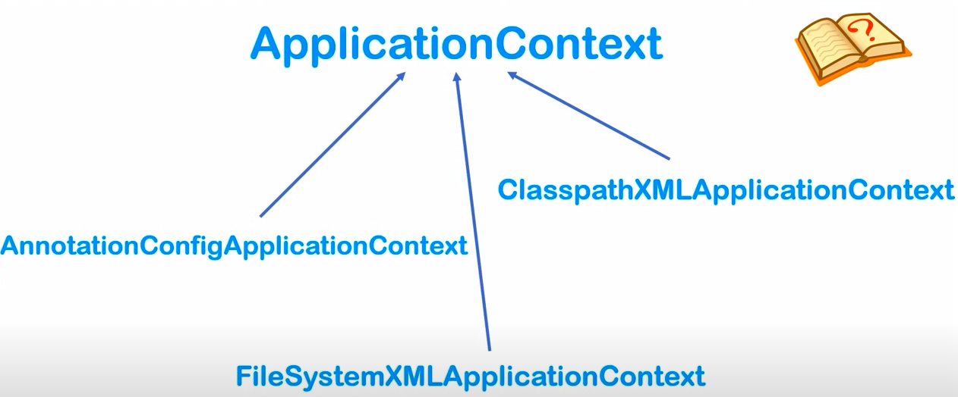

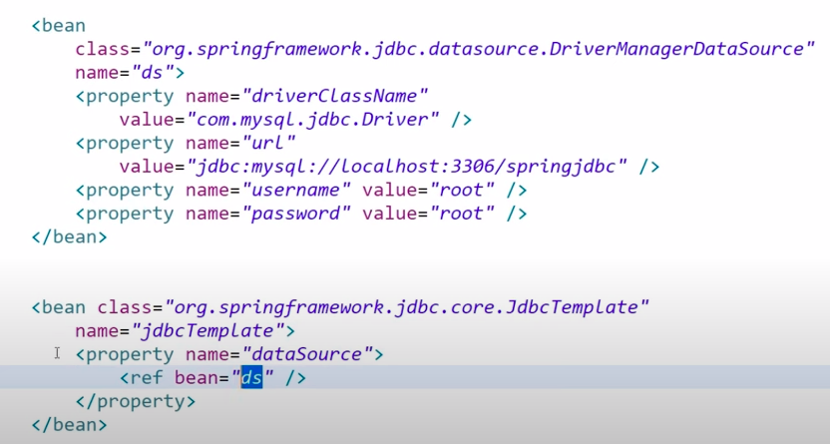

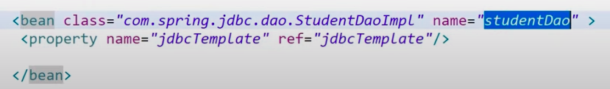

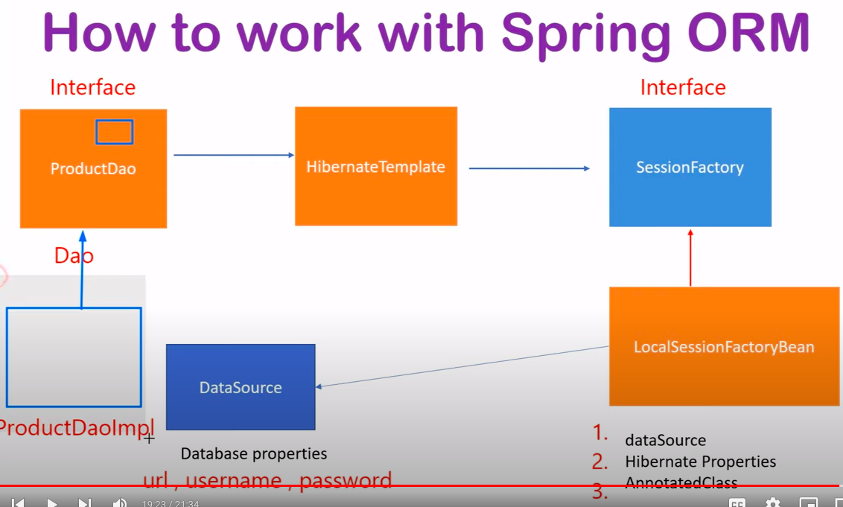

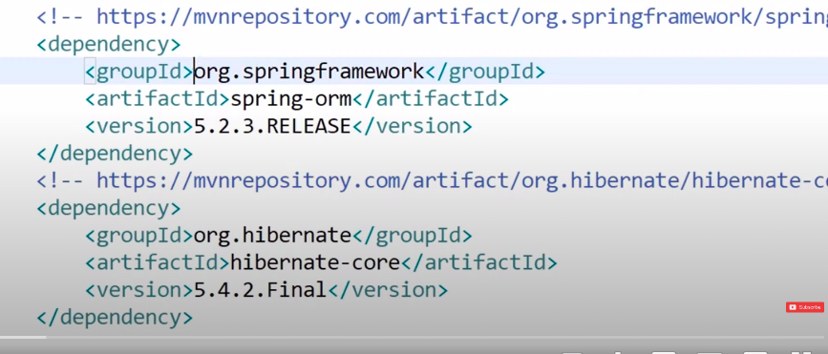

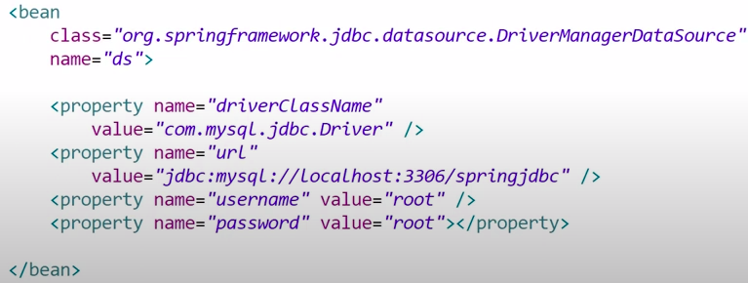

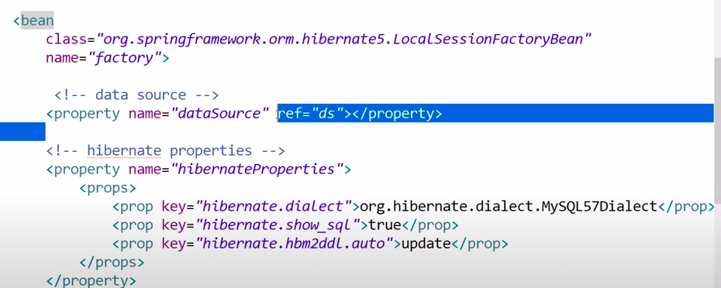

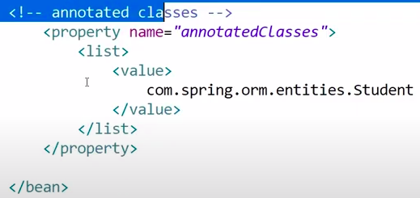

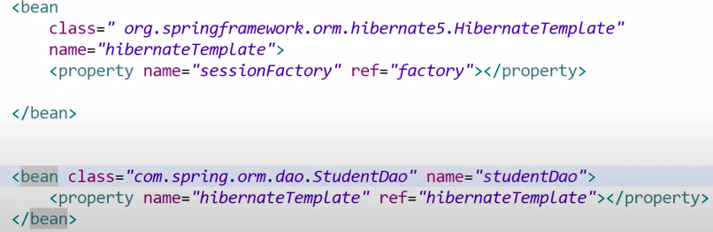

Add bean for the write properties

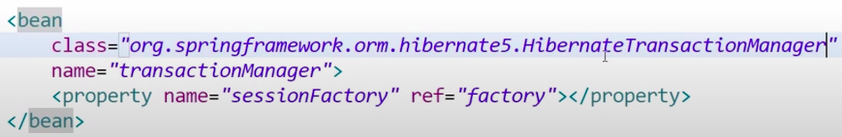

And add @Transactional above the method of create and update for write in database.

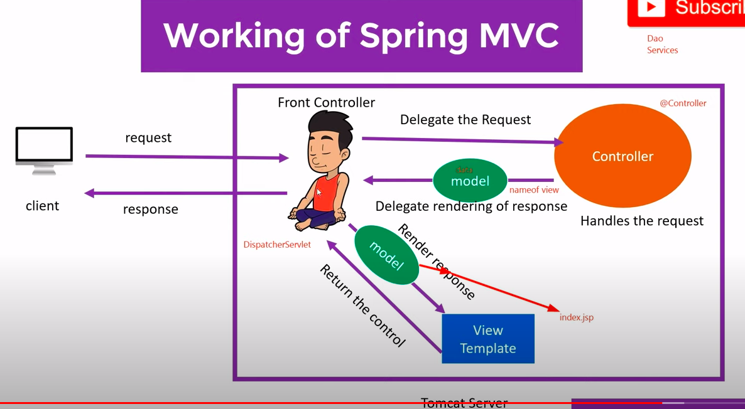

Add pom.xml **spring-webmvc** dependencies is used for the implementation of the Web MVC.

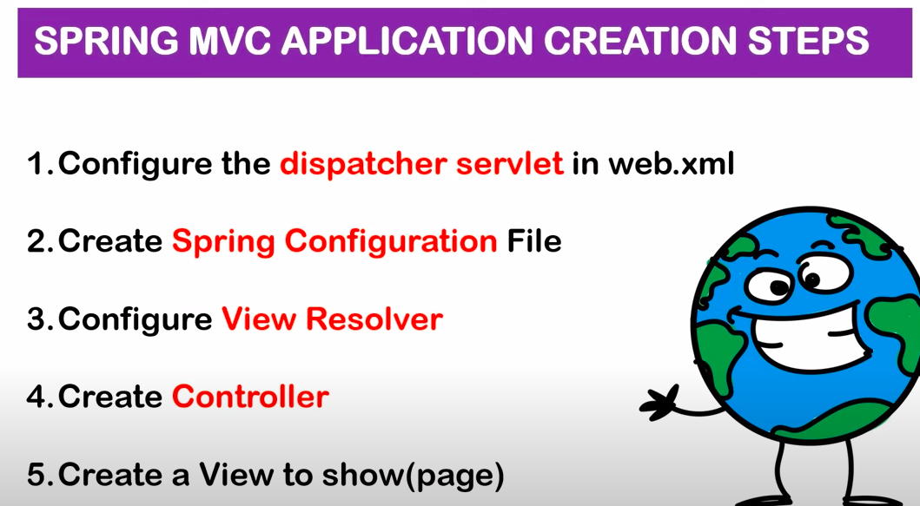

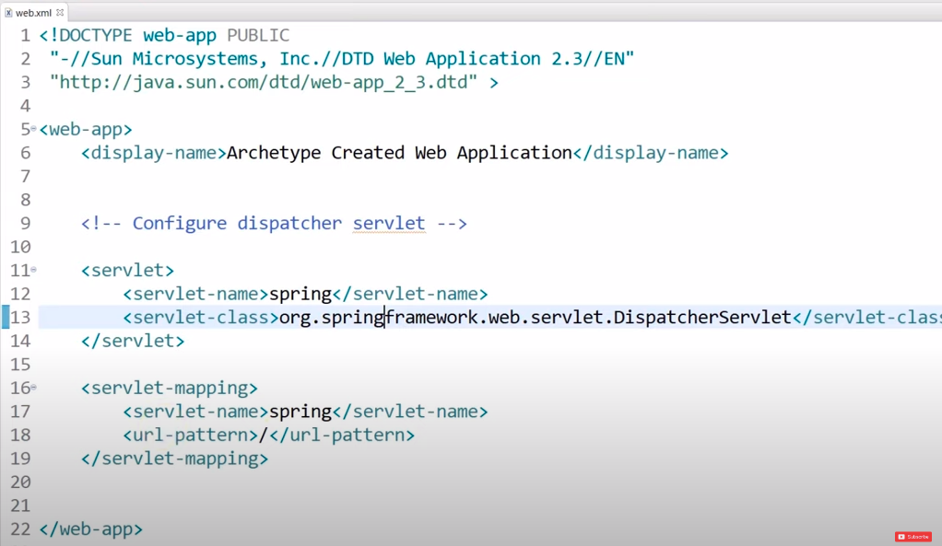

**spring-servlet.xml**

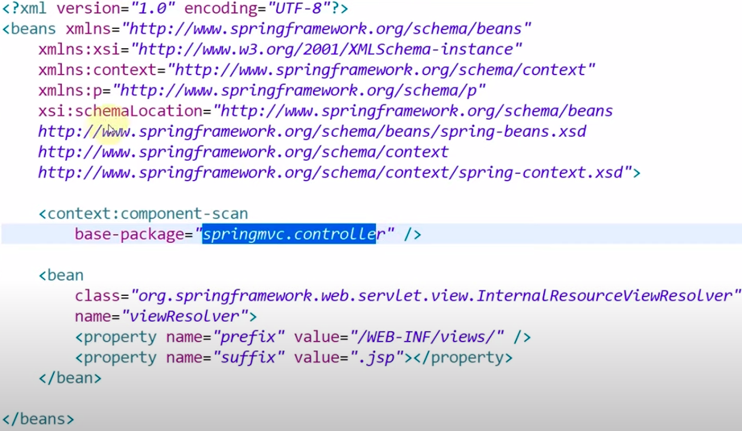

Aspect:

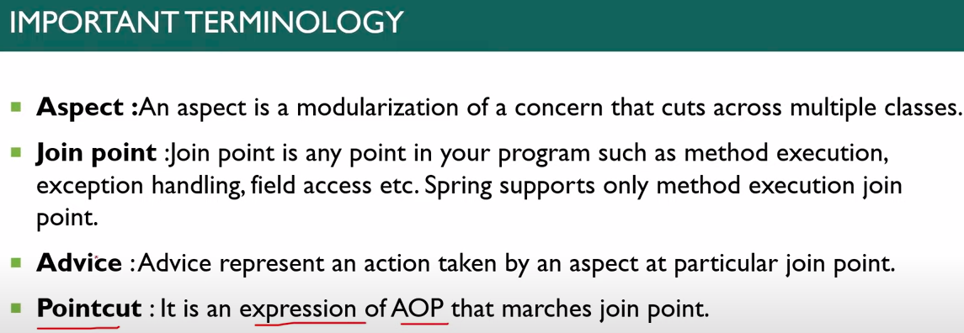

Spring latest version is 6.1.3.

Spring boot version is latest 3.2.0.

It is a Spring module that provides the RAD (Rapid Application Development) feature to the Spring Framework.

Spring Boot offers embedded servers such as Jetty and Tomcat, etc.

Layers of spring boot application: (PBPD)

1. Presentation Layer: The presentation layer handles the HTTP requests, translates the JSON parameter to object, and authenticates the request and transfers it to the business layer. In short, it consists of views i.e., frontend part.
2. Business Layer: The business layer handles all the business logic. It consists of service classes and uses services provided by data access layers. It also performs authorization and validation.
3. Persistence Layer: The persistence layer contains all the storage logic and translates business objects from and to database rows.
4. Database Layer: In the database layer, CRUD (create, retrieve, update, delete) operations are performed.

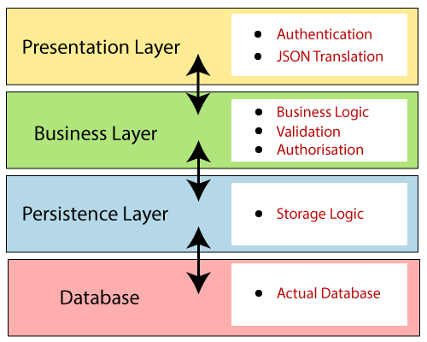

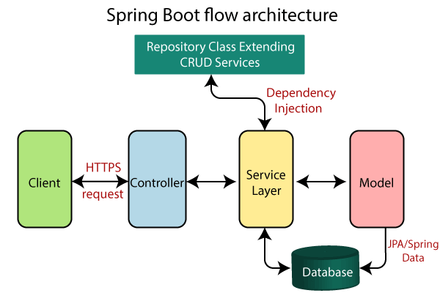

**Annotations:**

1. @Required: It applies to the bean setter method. It indicates that the annotated bean must be populated at configuration time with the required property, else it throws an exception BeanInitializationException.
2. @Autowired: Spring provides annotation-based auto-wiring by providing @Autowired annotation. It is used to autowire spring beans on setter methods, instance variables, and constructor. When we use @Autowired annotation, the spring container auto-wires the bean by matching data-type.

IOC Container is responsible for injecting the dependency.

1. @Configuration: It is a class-level annotation. The class annotated with @Configuration used by Spring Containers as a source of bean definitions.
2. @ComponentScan: It is used when we want to scan a package for beans. It is used with the annotation @Configuration. We can also specify the base packages to scan for Spring Components.
3. @Bean: It is a method-level annotation. It is an alternative to the XML <bean> tag. It tells the method to produce a bean to be managed by Spring Container.
4. @Component: It is a class-level annotation. It is used to mark a Java class as a bean. A Java class annotated with @Component is found during the classpath. The Spring Framework picks it up and configures it in the application context as a Spring Bean.
5. @Controller: The @Controller is a class-level annotation. It is a specialization of @Component. It marks a class as a web request handler. It is often used to serve web pages. By default, it returns a string that indicates which route to redirect. It is mostly used with @RequestMapping annotation.
6. @Service: It is also used at class level. It tells Spring that class contains the business logic.
7. @Repository: It is a class-level annotation. The repository is a DAOs (Data Access Object) that accesses the database directly. The repository does all the operations related to the database.
8. @EnableAutoConfiguration: It auto-configures the bean that is present in the classpath and configures it to run the methods. The use of this annotation is reduced in Spring Boot 1.2.0 release because developers provided an alternative of the annotation, i.e. @SpringBootApplication.
9. @SpringBootApplication: It is a combination of three annotations @EnableAutoConfiguration, @ComponentScan, and @Configuration.
10. @EnableAutoConfiguration(exclude={Test.java, Test1.Java}, excludeName = “com.test”)

**Spring MVC and REST Annotations**

1. @RequestMapping: It is used to map the web requests. It has many optional elements like consumes, header, method, name, params, path, produces, and value. We use it with the class as well as the method.
2. @GetMapping: It maps the HTTP GET requests on the specific handler method. It is used to create a web service endpoint that fetches It is used instead of using: @RequestMapping(method = RequestMethod.GET)
3. @PostMapping: It maps the HTTP POST requests on the specific handler method. It is used to create a web service endpoint that creates It is used instead of using: @RequestMapping(method = RequestMethod.POST)
4. @PutMapping: It maps the HTTP PUT requests on the specific handler method. It is used to create a web service endpoint that creates or updates It is used instead of using: @RequestMapping(method = RequestMethod.PUT)
5. @DeleteMapping: It maps the HTTP DELETE requests on the specific handler method. It is used to create a web service endpoint that deletes a resource. It is used instead of using: @RequestMapping(method = RequestMethod.DELETE)
6. @PatchMapping: It maps the HTTP PATCH requests on the specific handler method. It is used instead of using: @RequestMapping(method = RequestMethod.PATCH)

Use for the partial update. Like only we need to update the name of the User.

1. @RequestBody: It is used to bind HTTP requests with an object in a method parameter. Internally it uses HTTP MessageConverters to convert the body of the request. When we annotate a method parameter with @RequestBody, the Spring framework binds the incoming HTTP request body to that parameter.

In Mvc we have @ModelAttribute

1. @ResponseBody: It binds the method return value to the response body. It tells the Spring Boot Framework to serialize a return object into JSON and XML format.
2. @PathVariable: It is used to extract the values from the URI. It is most suitable for the RESTful web service, where the URL contains a path variable. We can define multiple @PathVariable in a method. URL: **test/10**
3. @RequestParam: It is used to extract the query parameters from the URL. It is also known as a query parameter. It is most suitable for web applications. It can specify default values if the query parameter is not present in the URL. **?a=10**
4. @RequestHeader: It is used to get the details about the HTTP request headers. We use this annotation as a method parameter. The optional elements of the annotation are name, required, value, defaultValue. For each detail in the header, we should specify separate annotations. We can use it multiple time in a method
5. @RestController: It can be considered as a combination of @Controller and @ResponseBody annotations. The @RestController annotation is itself annotated with the @ResponseBody annotation. It eliminates the need for annotating each method with @ResponseBody.
6. @RequestAttribute: It binds a method parameter to request attribute. It provides convenient access to the request attributes from a controller method. With the help of @RequestAttribute annotation, we can access objects that are populated on the server-side. We can get the attributes that is set in the request using the req.setAttribute(‘test’,’test’);

Get using the @RequestAttribute(‘test’) String

**For Run the Spring boot application from the terminal: (Must be same Java version)**

$mvn spring-boot:run, $gradle bootRun

Run jar file: Java -jar test.jar

$ java -Xdebug -Xrunjdwp:server=y,transport=dt_socket,address=8000,suspend=n -jar target/myapplication-0.0.1-SNAPSHOT.jar

**Application.properties/ application.yml**:

located inside the src/main/resources folder.

**@Bean LifeCycle: container start -> Bean initialized -> dependencies injected -> init() -> custom utility method -> Destroy.**

@PostConstruct, @PreDestroy

If we need to do that from the XML Configuration there is two interfaces: Serializabal Bean and Desposable Bean.

init() -> destroy()

**Rest Clients:** Rest Template to call the third party apis

Different between getForObject vs getForEntity:

getForObject: returns the only object

getForEntity: return the entity with the header and status code and body

Exchange, and execute other methods.

@GetMapping(path = "/{contactId}")

public **ResponseEntity**<Contact> getContacts(@PathVariable("contactId") Long contactId) {

System.out.println("Contact Id is : " + contactId);

return ResponseEntity.status(HttpStatus.OK).body(contactServiceImpl.findById(contactId).orElse(null));

}

@GetMapping(path = "/{contactId}")

public **Contact** getContacts(@PathVariable("contactId") Long contactId) {

System.out.println("Contact Id is : " + contactId);

return contactServiceImpl.findById(contactId).orElse(null);

}

ReadTimeOut and ServerTimeOut:

ServerTimeout: server is not reachable

ReadTimeOut: service is available but the content for read is not available.

Versioning in REST: we can maintain the the

With params

@GetMapping(path = "/{contactId}", params=xyz=1)

@GetMapping(path = "/{contactId}", params=xyz=2)

With headers

@GetMapping(path = "/{contactId}", header=api-xyz-1)

@GetMapping(path = "/{contactId}", header=api-xyz-2)

With produces

@GetMapping(path = "/{contactId}", produces=application/version1+json)

@GetMapping(path = "/{contactId}", produces=application/version2+json)

With uri

@GetMapping(path = "v1/{contactId}")

@GetMapping(path = "v2/{contactId}")

Authentication in Rest API:

Authentication Filter -> authentication Builder ->Authentication Provider -> AuthenticationManagerbuider -> SecurityContext

Security Configuration Class extend the **WebSecurityConfigurationAdapter**

**Two configuring Methods of classes:**

**configuration(authenticationManagerBuilder)**

**configuration(WebSecurity)**

**configuration(HttpSecurity)**

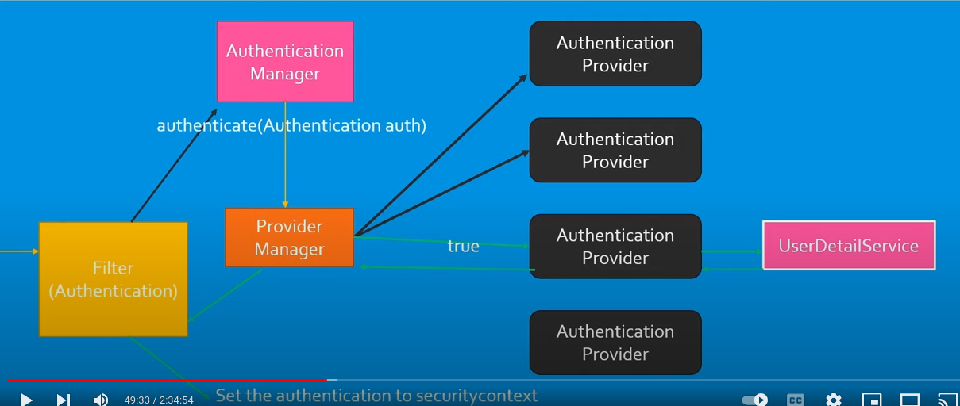

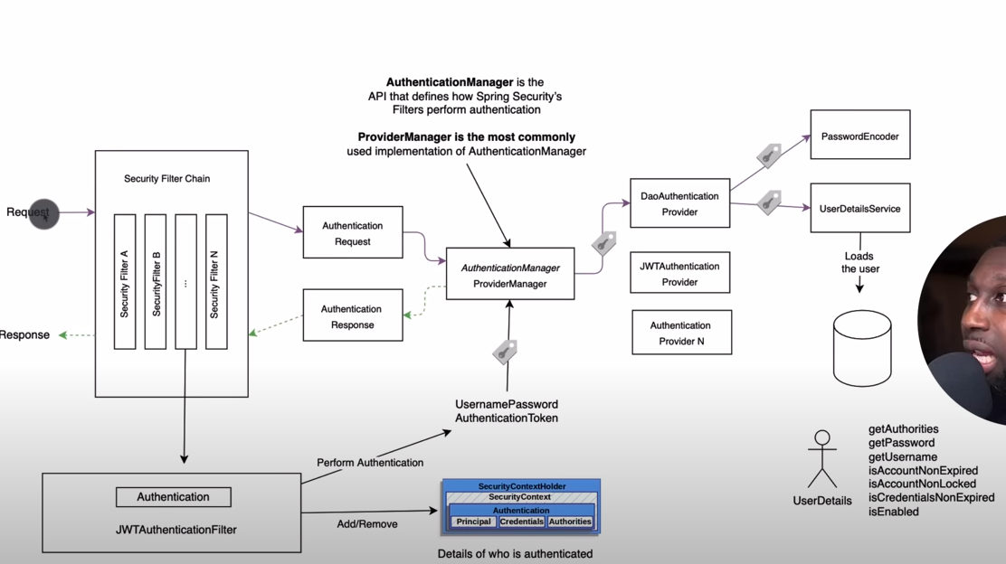

**Session Based vs JWT token based authentication:**

In rest we prefer to Token based Authentication, session based auth in restricted to particular one system. In another system the same session doesn't work.

Content Negotiation: what the api produces and consumes in xml or json.

In microservice any security and cross cutting conscience and add in the API Gateway microservices.= **Microservice Architecture.**

Custom Validator in Spring boot:

Extend the CustomValidator. Annotation @retaintion @runtime @interface

@Constraint(validatedBy = FieldsValueMatchValidator.class)

@Target({ ElementType.TYPE })

@Retention(RetentionPolicy.RUNTIME)

public @interface FieldsValueMatch {

String **message**() default "Fields values don't match!";

String **field**();

String **fieldMatch**();

}

Validation form : @RestControllerAdvice, @ExceptionHandler(UserNotFoundException.class)

Bean validation and Hibernate Validation

**Auditing With the Spring Envers: envers = track data changes at the entity level**

Repository: interface PersonRepository extends CrudRepository<Person, Long>, **RevisionRepository<Person, Long, Long>** {}

Call: Revisions<Long, Person> revisions = repository.**findRevisions**(updated.id);

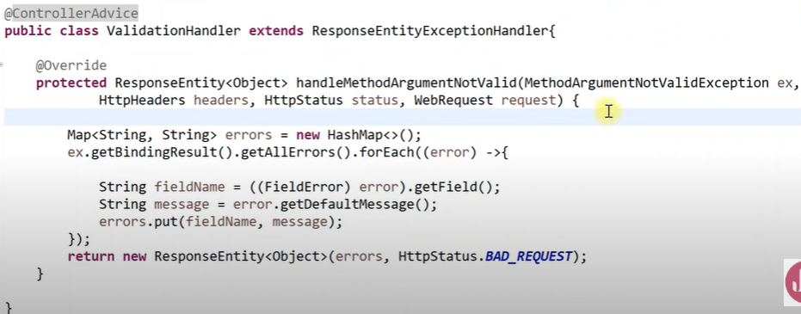

PathParam Validation: <https://www.baeldung.com/spring-validate-requestparam-pathvariable>

1. Dependency Injection: (laptop and hard disk example) no need to test hard disk because it’s already tested only need to test laptop. IOC container is responsible to inject the dependency.

There are two types of IoC containers. They are:

1. BeanFactory
2. ApplicationContext

Two ways to perform Dependency Injection in Spring framework

1. By Constructor
2. By Setter method
3. By property injection

@Component

@Scope(value = "") = singleton, application, prototype, request, session (default = Singleton)

**Use Jasper dependency to load the content of the Jsp:**

https://mvnrepository.com/,/org.apache.tomcat/tomcat-jasper

@RepositoryRestResource(collectionResourceRel=””,Path=””)

<dependency>

<groupId>org.springframework.boot</groupId>

<artifactId>spring-boot-starter-data-rest</artifactId>

<version>1.2.5.RELEASE</version>

</dependency>

**Spring Boot Staters:**

spring-boot-starter-web, spring-boot-starter-test, spring-boot-starter-data-jpa, spring-boot-starter-mail, spring-boot-starter-jdbc, spring-boot-starter-actuator, spring-boot-starter-aop, spring-boot-starter-batch, spring-boot-starter-cache, spring-boot-starter-tomcat, spring-boot-starter-redis, spring-boot-starter-mongo

**MicroServices**

**Disadvantage** of the **monolithic Architecture**:

When application Scale it’s difficult to manage.

For Single change, we need to redeploy all the modules

Difficult to manage the different code base with the different code technologies.

A single bug can down a complete application.

**Advantage** of the **monolithic Architecture**: Simple to build, deploy and develop.

Network delay is late to communicate between two api modules, because it is in the single code base.

Microservice calls each api interconnected with HTTP protocol.

User -> API Gateway (provide single entry point for the different APIs) -> API1, API2, API3

API Gateway: Use for the security and authentication related stuff. Cross cutting curson also add in api gateway

API gateway created using the **Zaul or Spring cloud gateway**.

**Hystrix Dashboard, Resilience4j: Use for the Fault to tolerance**.

Eureka Service Discovery: we are registering all the services on API. port: 8761

Eureka client dependency is used for the register of the apis.

Config Server: to store all the comment configurations used in the all three APIs.

**Hystrix:**

Create a call back method, when the api fails then the callback function is called automatically.

Fault Tolerance Library: can check which api have issue and monitor the service in the micro service

Add hystric and actuator dependency in API Gateway for the fault tolerance in the micro service.

Total API:

1. API Gateway - eurekaClient
2. UserAPI, ContactAPI - eurekaClient
3. Eureka Server and register all 1, 2 APIS. - eurekaServer
4. Hystrix API - eurekaClient
5. ConfigAPI - eurekaClient

Call third party API

<https://www.youtube.com/watch?v=QPiAhiUwb4I>

Rest Template is decrypted now user WebClient.

<https://medium.com/naukri-engineering/resttemplate-is-deprecated-use-webclient-a1dd7ca6394d>

Manage the log files - slf4j

youtube.com/watch?v=bt8DZUmgy8M

ForignKey:

[Person class]

@OneToOne(cascade = CascadeType.ALL, optional = false)

@JoinColumn(name = "id_card_id")

private IDCard idCard;

[IdCard class]

@OneToOne(mappedBy = "idCard")

private Person person;

One person has one id card

URL : https://hellokoding.com/jpa-one-to-one-foreignkey-relationship-example-with-spring-boot-maven-and-mysql/

Mapping:

One to One: Egger load

One User, One Address

User:

@OneToOne(cascade=Cascade.ALL)

@JoinColumn(name=”address_id”,referenceColumnName=”id”)

Address address;

Address:

@OneToOne(mappedBy=”address”)

User user;

OneToMany: lazy load. We need to load all the comment once the post is loaded so we user Eager.

Post:

@OneToMany(cascade = CascadeType.ALL, fetch = FetchType.EAGER)

@JoinColumn(name = "post_id", referencedColumnName = "id")

Set<Comment> comments = new HashSet<>();

Comment:

@Column(name = "post_id")

Long postId;

ManyToMany: lazy load

Employee:

@ManyToMany(fetch = FetchType.EAGER, cascade = CascadeType.ALL)

@JoinTable(

name = "employee_roles",

joinColumns = @JoinColumn(

name = "employee_id", referencedColumnName = "id"

),

inverseJoinColumns = @JoinColumn(

name = "role_id", referencedColumnName = "id"

)

)

Set<Role> roles = new HashSet<>();

Role:

@ManyToMany(mappedBy = "roles")

@JsonIgnore

Set<Employee> employees = new HashSet<>();

ManyToOne:

Employee:

@ManyToOne

@JoinColumn(name = "department_id", referencedColumnName = "employees")

private Department department;

Department:

@OneToMany(mappedBy = "department")

private List<Employee> employees;

**Spring Boot Actuator Features**

Endpoints: /actuator/health

Metrics: metrics by integrating with the micrometer

Audit: audit framework that publishes events to an AuditEventRepository

Health

Info

Beans

Mappings

Configprops

Httptrace

Heapdump

Threaddump

Shutdown

**Catching in Spring Boot**

* In-memory Caching
* Database Caching
* Web server Caching
* CDN Caching

Exception Generic Class = DataAccessException

1. 5 Exception that you know in spring boot

NoSuchBeanDefinationException: comes when we autowired the class that is not annotated with the @Component

NoUniqueBeanDefinitionException: if we have to classes that implements the same interface and we autowired that interface that time it throws

to overcome that we have the @qulifire annotation with the autowired or @primary annotation in the class.

BeanCreationException: Circular Dependency then that throws that error. (emp<->dep). we have the **@lazy** annotation. Or we use **@primary** annotation to solve the circular dependency issue.

BeanInstantiationException: when we Instantiate the Abstract class

ApplicationContextException: when we miss the @SpringbootApplication annotation.

How to resolve the circular Dependency: using the @Primary and @Lazy, using the setter injection, @PostConstruct

classA {

B circB;

@PostConstruct

public void init() {

circB.setCircA(this);

}

}

2. Spring annotations Excluding the stereotype annotations:

stereotype annotation: annotation that is used to instantiate the Spring bean.

@NoRepositoryBean: when we don't pick the class by the spring container and not instantiate.

@DataJPATest

Spring security annotations:

@secure

@EnableWebSecurity

@Runnable

@preAuthorized

@postAuthorized

Why we use @Service annonataion in top of the DAO implementation Insted of @Componnt.

-> Because if we have use @Component annotation it is also working but some exception not send to that layer. Like DataAccessException and all related to the database.

-> If new feature come in future related to service layer not get reflected of we use @Component annotation.

3. Why @Repository is require:

Repository -> CRUDRepository -> PaginationAndSortingRepository -> JPARepository

Data JPA = Spring Data JPA -> Spring Data Provider (Hibernet) -> Database

4. Java Config File and limitation:

Use to instantiate the Database and RestTemplate.

@conditional to when the object is created.

@importResource to load the xml configuration file.

Limitation: we don't have the configuration class and methods final. because the child class can extend the parent config.

5. Different between the @bean and @component:

@component: create bean without conditionals.

@bean: we can add the Conditions on bean. @conditional

6. BeanFactoryPostProcessor: Is the interface. have method BeanPostPeocessor() for customizing the metadata.

BeanFactoryPostProcessor: call before the spring bean Initialization

BeanPostProcessor: call After the spring bean Initialization

7. @transactional Propagation: Create the FakeTransactionIterceptorProxy by spring it validates the results then if it is successful then only it commits in the database.

we add the transactional inside the aspectj method. Propagation is to carry forward the transaction.

**Aspect:**

**@EnableAspectJAutoProxy**

AspectJ: @Before, @After, @AfterReturn, @AfterThrowing, @Around

<https://www.youtube.com/watch?v=Og9Fyew8ltQ>

<https://www.youtube.com/watch?v=inrzWswf8N0>

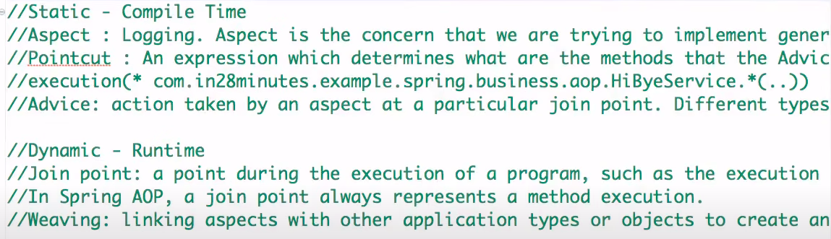

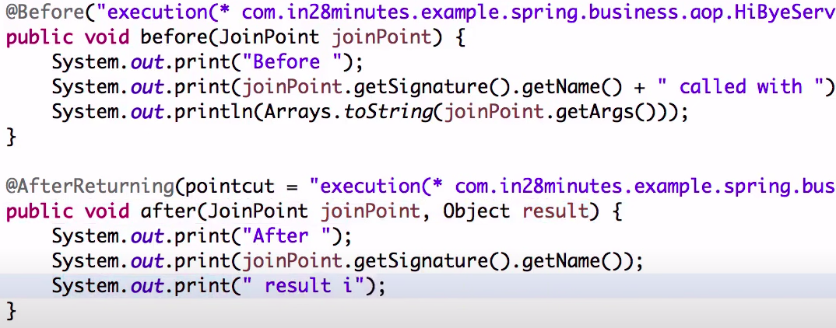

@Before(* com.test.*(..))

Java Questions:

Serialization, Deserialization = convert the object to byte to reuse the object

Clonable= cloning = Object copy

Deep Copy and Shallow Copy:

Shallow copy can copy the address of the object and store it in another location. Store only one object

Deep copy can copy the object and store the other object.

Memory Leak issues handle in java = Visual Vm Tool

Actuator = user to check the performance of the APIs, use for the fault tolerance.

Qualifier vs Primary:

Qualifier = by type, name we can add to the bean execution process

Primary: we can give the preference to the bean.

ResponseEntity and Response body: Entity = use to send the response, header. In Response: we need to send the Entity response.

PathParameter and PathVariable: @PathParam can be used with REST only, whereas @PathVariable used in Spring so it works in MVC and REST.

How to protect the rest api from the third party.

* Two ways

- session based Authentication

jwtSecret

Samls

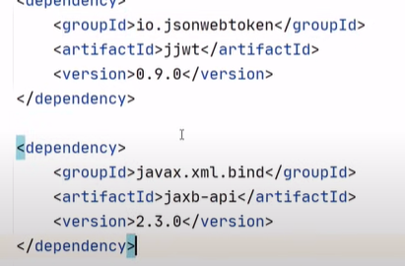

**JWT UTIL CLASS**

https://github.com/koushikkothagal/spring-security-jwt/blob/master/src/main/java/io/javabrains/springsecurityjwt/util/JwtUtil.java

**Functional Interface:** only one Abstract method and many static and default methods.

**Lambda Function:** No function name and return type. Two Examples: Cloneable and Runnable, predicate, Function.

**Predicate:**  It improves manageability of code, helps in unit-testing them separately, and contains some methods like.

Methods: isEqual(Object targetRef) , and(Predicate other) , negate() , or(Predicate other), test(T t).

import java.util.function.Predicate;

public class PredicateInterfaceExample1 {

public static void main(String[] args)

{

// Creating predicate

Predicate<Integer> lesserthan = i -> (i < 18);

// Calling Predicate method

System.out.println(lesserthan.test(10));

}

}

**Questions and Answers:**

**Why string are immutable.** Because String class as final class so we can not extend that class. And once we initilize then we can’t chage that.

Once the string is initilize then that is store inside the string cache pool and the hashcode is calculate for the character array and store the string in that location.

When we have the string then that time it calculate the hashcode again and if there is the string the point to that same address.

Ex: String str1 = “Hello”;

String str2 = “Hello”; that both the variable point to the same location based on the hash code calculation.

Immutable becuase

Caching = when compiler optimizes your String objects, it sees that if two objects have same value (a="test", and b="test") and thus you need only one string object

security = pass the parameter in request url with the string,

synchronization = automatically makes them thread safe

performance.

Class loading: String is used as arguments for class loading.

Java 8 features.

Stremapi its uses.

Functional interface.

What is a predicate function? - done

Microservices and its uses -

Which Design patterns you have used. - done

- design pattern in java :: explain singleton and factory pattern - done

number of ways to create threads - done

threadpool execution -done

callable interface - done

- difference between join and wait method - done

- what is marker interface? - done

- why is synchronization important? - done

- disadvantage of synchronization. - done

- what is a concurrent hashmap? - done

- how equals and hashcode works? - done

- why concurrent exceptions occur while using a multi thread application? - done

- how hashcode initialized? - done

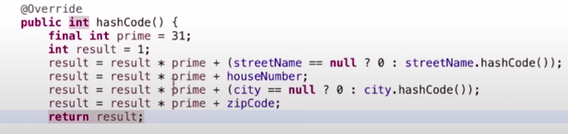

- isa relationship and hasa relationship. - done

- what is aggregation and composition? - done

- what is method overloading and method overriding? - done

Hibernate configuration on spring: session factory(singleton) -> create the session object - done

How do you do logging? - done

explain logging mechanism - done

Spring security. - done

Spring Boot architecture.

Microservices architecture..

what is rest template - done

- What is dependency injection? - done

- Type of dependency injection? - done

- Tight coupling and loose coupling. - done

- different types of bean scopes? - done

- what is a session? What is the purpose? - done

- what is first level cache and second level cache? -done

S3 bucket

EC2 instance

HackerRank practice assignment

**Answers:**

**Design patterns:**

use composition over inheritance.

code for interface not for the implementation

Type of design patterns:

Creational: use when we create the object

types:

Singleton

Abstract Factory

Factory

Builder

Prototypes

Structural: use when we require object inside the object, or we need to Compose with two object (Compose) then we use the Structural patterns

types:

Adapter

Composite

Proxy

Fly Weight

Facade

Bridge

Decorators

Behaviour: make communication between two objects then we use the behaviour design patterns.

type:

Template Method

Mediator

Chain of Responsibility

Observer

Strategy

Command

State Visitor

Iterator

Interpreter

memento

Hibernate configuration on spring: session factory(singleton) -> create the session object

Add the libraries for the hibernate in the project classpath.

Add bean in spring.xml to make the sessionFactory Singleton and add the hibernate configuration.

**Thread**

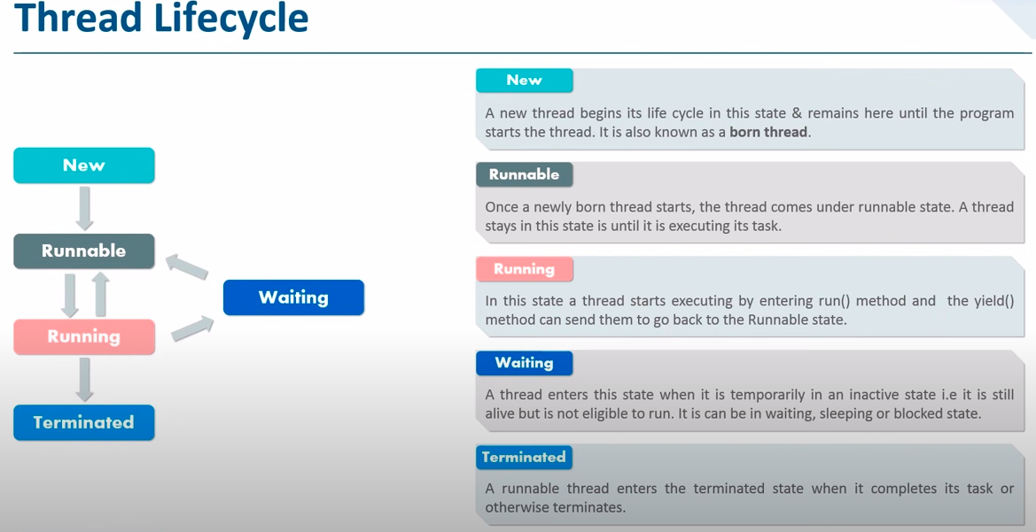

number of ways to create threads:

thread.start() = can start to execute the run method.

Extends the thread class,

Runnable Interface

Runnable interface is better because we do not have support for Multiple Inheritance.

Callable interface = use Executor Service to run the thread

Join and wait and sleep:

both are used to pause the current thread.

The wait() is used in with notify() and notifyAll() methods: user for the resource sharing

join() is used in Java to wait until one thread finishes its execution: wait a thread to die.

wait() releases the lock while

sleep() doesn’t release any lock while waiting.

wait() is used for inter-thread communication

sleep() is used to introduce a pause on execution, generally.

notify(): The thread class notify() method is used to wake up a single thread.

notifyAll(): The notifyAll() wakes up all threads that are waiting on this object’s monitor.

threadpool execution:

The thread pool contains any number of the Thread.

Every thread can run one task at a time from the task Queue.

callable vs Runnable interface:

callable interface have call method, Runnable interface has run method.

Callable is called only with the Thread Executor service we cant use that with the Thread t= new Therar(new Callable interface) because it only have the runnable interface in thread class.

Callable interface call method return the string. Runnable interface run method doesn’t return any value.

Callable: throw exception and return the result, runnable don't throw or return value

Executor converts the Runnable to callable.

ExecutorService can convert you callable to future.

make a callable and runnable interface when the object of the class is accessed by another thread.

what is marker interface:

Marker Interface which do not have any methods or constants, It shows only runtime information about the objects

It is also called a tagging interface.

Ex: You need to create the object of the class if User has the permission, then we can create an interface implementing that Interface to the class, then check **classObj instanceOf InterfaceName**, if yes then proceed.

We have Serializable, Remote is the marker Interface in java.

synchronization:

wait another thread once the one thread completes the execution of the process.

Two types:

Mutual Exclusive

- by sync block

- by sync method

- by static sync

Cooperation: inter thread communication

- wait

- notify

- notifyAll

- Disadvantages of synchronization. - performance issue, delay in getting the output

concurrent hashmap:

A concurrent hashmap is thread safe. The default size and concurrency level is 16 for the hash table.

using the locking strategy for the different buckets/segments of the hash table.

read operations are not blocked by the lock.

Write operations are only done by one segment by only one thread.

disadv: not get the updated values

why concurrent exception occur while using multi thread application:

because at a time only one thread can access the single resource, for other threads that resource is blocked.

Deadlock prevention in the DBMS: Wait and Die, Wound wait, Lock timeout

Is-A relationship: Whenever one class inherits another class, it is called an IS-A relationship. also called Inheritance.

Has-A relationship: Whenever an instance of one class is used in another class, it is called HAS-A relationship. also called composition.

Example: Pulser IS-A Bike

Pulser Has-A Engine

Person Has-A Address

**Inheritance:** (IS-A Relation) Ex: Vehicle parent class, Car is the child class.

**Association**: (HAS-A Relation)

Association is a relation between two separate classes which establishes through their Objects.

one-to-one, one-to-many, many-to-one, many-to-many.

Composition and Aggregation are the two forms of association

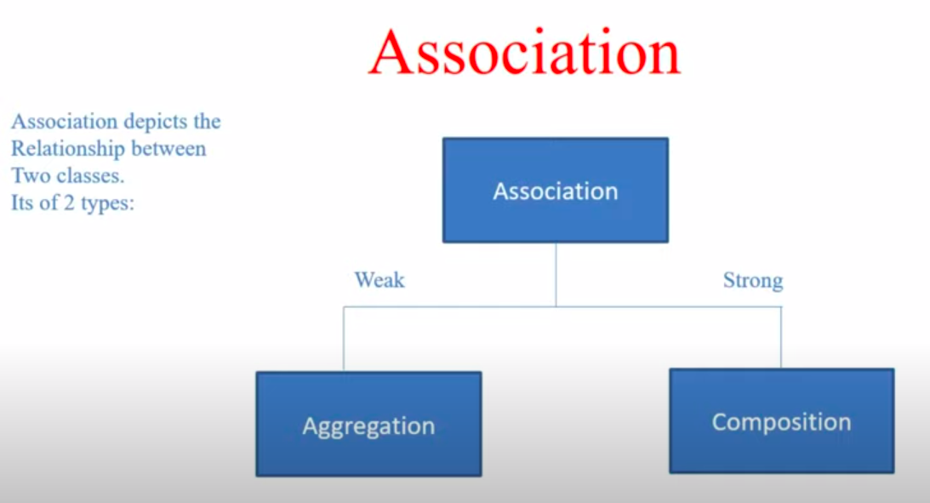

**Aggregation**:

It represents **Has-A’s relationship**.

It is a unidirectional association i.e. a one-way relationship. For example, a department can have students but vice versa is not possible and thus unidirectional in nature.

In Aggregation, both the entries can survive individually which means ending one entity will not affect the other entity.

Ex: Car <- ____Week Relation ____-> Driver

**Composition**:

**Composition** is a restricted form of Aggregation in which two entities are highly dependent on each other.

It represents **part-of a relationship**.

In composition, both entities are dependent on each other.

When there is a composition between two entities, the composed object cannot exist without the other entity.

Ex: Car <- _______ Tight Relation _______ -> Engine

equals and hashcode:

equals check for two object equal based on the memory location condition

hashcode compare the code of the objects

if two objects are equals then the hashcode of the two objects are the same.

if hashcode is the same doesn't mean that two objects are the same.

Spring Security:

Authentication: check the username and password

Authorization: Giving the permissions to the authenticated user.

Filter: Pre or Post action of the request.

BasicAuthentication: pass the Authorization: Basic token in the postman to get the result

FormBasedAuthentication: add the cookie sessionId in the header to call the api

CSRF: Cross site Request Forgery: if the user is not from the browser and tries to access the resource then we need to restrict the access.

CORS: (Cross Origin Requests) we need to authenticate the host, port and the protocol - http, https.

Generate the **csrf token** and validate the request.

@PreAuthorized("hasRole('admin')"): add the role based authentication using the annotation

@EnableGlobalMethodSecurity(prePostEnabled=true): add that annotation in the configuration class, to use the annotation based role authentication.

Logging in SpringBoot

- configure manually (log level, destination where it stores)

Logger log = LoggerFactory.getLoggeer(ClassName.Class) form the slf4j

set log properties in application.properties:

logging.level.root=TRACE

logging.level.[packageName]=INFO

logging.pattern.file: set the date time message pattern in the log file.

logging.path= user to define the path of the log file

for xml based configuration: we have two files logback-spring.xml

Logback.xml

Hibernate Caching:

Types of Caching:

CDN Cache

In Memory Cache

Web Server Cache

Database Cache

First Level: If we have the one object that is accessing the data from the database then it takes from the first level of caching, hibernate by default maintains the First Level caching.

Second Level: If two object are fatching the same data from the database, so we need to enable the Second Level Caching,

Ehcache, OsCache, SWarmCache,Redis are the third party caching available.

Ehcache: add the echcache dependancy with the same as the hibernate version we use in the jpa.

add properties for 2nd level caching:

spring.jpa.properties.hibernate.cache.use_second_level_cache=true

spring.jpa.properties.hibernate.cache.region.factory_class=org.hibernate.cache.ehcache.EhCacheRegionFactory

spring.jpa.properties.javax.persistence.sharedCache.mode=ENABLE_SELECTIVE

Add @Cache(stretorgy) above the entity

Cache Update Stretorgy:

Cache Aside: read from the database and store in the Cache.

Write Through: write the value in the database and read that value from the database.

Write Behind: write the value using the Queue in syncroniyos manar, ready the value after that writes in the cache.

Refresh Ahead: refresh cache before the actual read from the data

**AWS**: No require the external hardware, easy to scale up and down, You have complete control, pay for what you use, and are highly secure.

**EC2**:

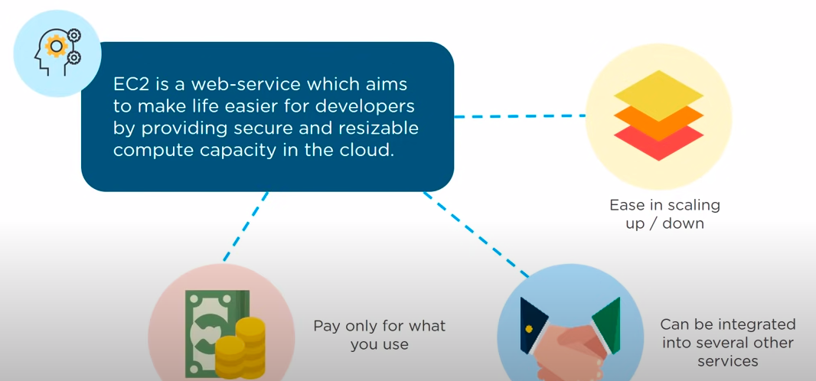

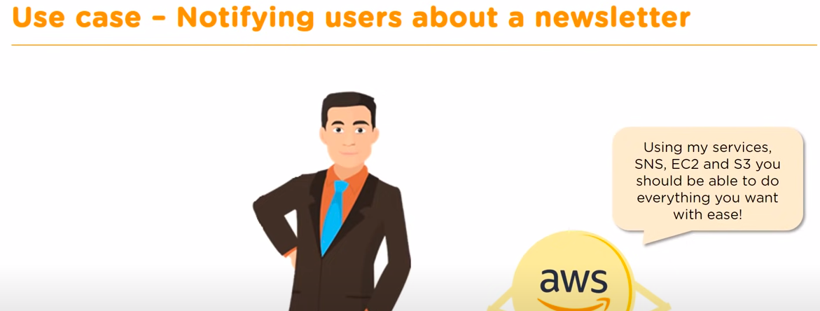

SNS: Sms notification service

EC2: scale up and down

S3: for the document store.

Steps For Creating the EC2 Instance:

1. Choosing an AMI (Amazon Machine Image): software, os, access permission.
   1. Predefined AMI
   2. Custom AMI
2. Choosing the Instance Type: Configure the Hardware Specification required by the AMI.
   1. Computer Optimized: processing power
   2. Memory Optimized: In memory cache
   3. GPU Optimized: Graphical requirements used for the Gaming purpose
   4. Storage Optimized: For Storage of the server.
   5. General Purpose: all are balanced by default.

We don’t customized the Instance type

1. Configure Instance: user to configure the number of Instance, Purchasing options, network, ip, IAM role, authentication, Stopping system and terminate system, add bootstrap Scripts etc.
   1. Payment Instances:
      1. Reserved Instance
      2. Spot Instance: bidding instance.
2. Adding Storage:
   1. EPhemeral Storage (temporary and free)
   2. Amazon Elastic Block Store ( permanent and paid)
   3. Amazon S3

Free user have 30 GB data

1. Adding tag: For Identifying the AMI system.
2. Security Groups: Firewall to Secure the web.
3. Review: review the configuration that we created and launch the instance.

After that we get the public and private key. Private key is the .pem file

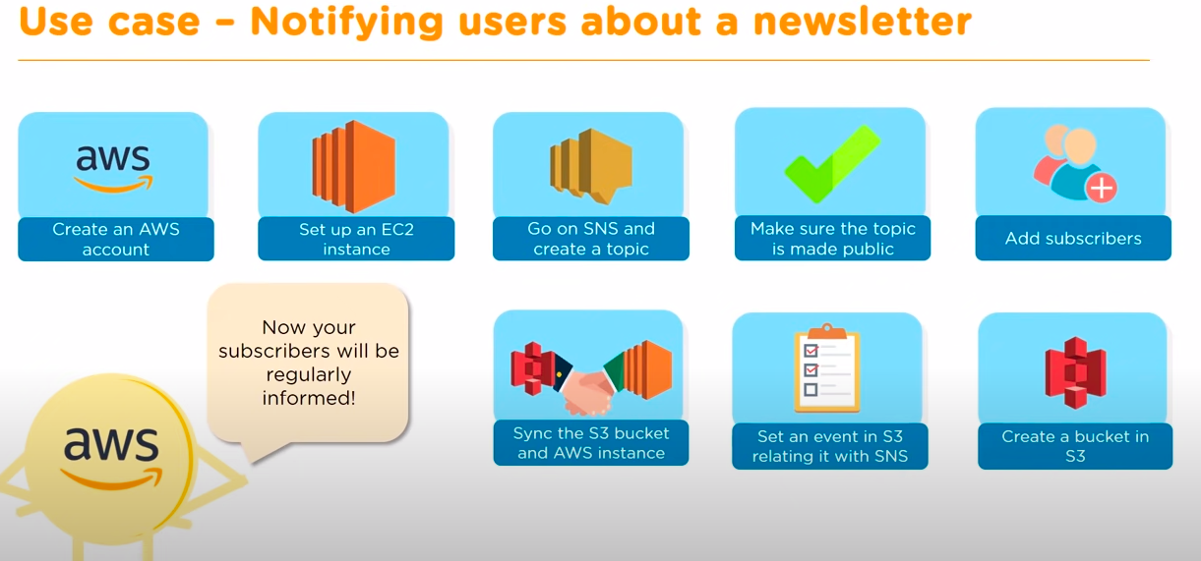

**Exception Handling in Spring Boot:**

@RestController

@ControllerAdvise: user to handle the Exception Globally. When we use the @ControllerAdvice we need to extend the ResponseEntityExceptionHandler.

@ExceptionHandler:

@ResponseStatus:

Two type we can handle the Exceptions:

1. Custom Exception
2. ControllerAdvice: @ControllerAdvice and @ExceptionHandler(Exception.class)

Exception handling the Rest APIs:

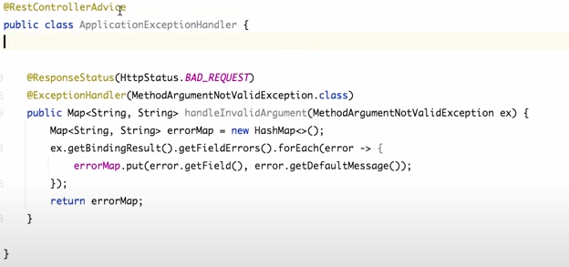

https://www.youtube.com/watch?v=gPnd-hzM_6A

**Collections:**

Comparator vs Comparable:

The Comparator provides multiple sorting sequences. In other words, we can sort the collection on the basis of multiple elements such as id, name, and price etc.

Comparable provides a single sorting sequence. In other words, we can sort the collection on the basis of a single element such as id, name, and price.

Comparator doesn't affect the original class, i.e., the actual class is not modified.

Comparable affects the original class, i.e., the actual class is modified.

Comparator provides compare() method to sort elements.

Comparable provides compareTo() method to sort elements.

A Comparator is present in the java.util package.

Comparable is present in java.lang package.

We can sort the list elements of Comparator type by Collections.sort(List, Comparator) method.

We can sort the list elements of Comparable type by Collections.sort(List) method.

HashMap vs HashSet:

Hashmap is from the Map Interface

HashSet is form the set Interface

One null key and multiple null values are allowed in the HashMap

Single null value allowed in HashSet.

Duplicate values are allowed in the Hashmap, no duplicate keys are allowed.

No duplicate aws are allowed.

Hashmap follows the hashing techniques.

Hashtable internally uses the Hashmap.

Hashmap creates two objects, one is for key and one is for the value.

Hashset creates only one object for the value.

Hashmap has put() method

Hashset has an add() method.

Hashmap is faster than hashset, because it uses the Hashing technique.

Hashset is slower than Hashmap.

Iterator vs Enumeration

In Iterator, we can read and remove elements while traversing elements in the collections.

Using Enumeration, we can only read elements while traversing elements in the collections.

It can be used with any class of the collection framework.

It can be used only with legacy classes of the collection framework such as a Vector and HashTable.

Any changes in the collection, such as removing elements from the collection during a thread is iterating the collection then it throws concurrent modification exceptions.

Enumeration is Fail safe in nature. It doesn’t throw concurrent modification exception

Only forward direction iterating is possible

Remove operations can not be performed using Enumeration.

It has following methods −

*hasNext()

*next()

*remove()

It has following methods −

*hasMoreElements()

*nextElement()

**Java 8 Features: Function Program, code Reusability, Bulk operation.**

**Lambda Expressions**

Don’t have any name and prefix, so it’s called an anonymous function.

Lambda expression helps us to write our code in a functional style. It is very useful in collection libraries in which it helps to iterate, filter and extract data.

Real time example if we have the book and we need to sort the book by name then we have two options: use comparator interface or use the lambda function.

1. Comparator interface:

Collections.sort(bookList, new Comparator<Book>() {

public int compare(Book o1, Book o2) {

return o1.getBookName().compareTo(o2.getBookName());

};

});

1. Lambda function:

Collections.sort(bookList, (o1, o2) -> o1.getBookName().compareTo(o2.getBookName()));

**Functional Interface:**

Only one abstract method, and many default and static method

Runnable - run(), Callable - call(), Comparable - compareTo(), Comparator - compare().

**Consumer, Predicate and Supplier: default functional Interfaces**

Consumer: user when we need to consume the object.

Take input and perform some operationsConsumer, Predicate and Supplier. It has a method **void accept(T t)** which doesn't return any value.

In Stream api **forEach((no)-> System.out.println(no))** that accepts the Consumer Interface.

Predicate: used for the conditional checking return boolean value.

It has one method **boolean test(T t)**

In Stream api:

intList.stream().filter(**(no) -> no > 50**).forEach(System.out::println);

Supplier: if there is no input argument but output is expected.

Method: **T get()**

In Stream api:

List<String> strList = Arrays.asList("q", "b");

System.out.println(strList.stream().findAny().orElseGet(**()-> {return "Not found";}**));

**Stream API:**

Process the collection of objects.

Take the input from the collection or array then convert that to stream.

Method: filter: for Conditional Checking , forEach: iterating the objects

Map and FlatMap = one to one mapping

FlatMap: map + flattering:, one to many mapping

Process the stream and return another stream. Ex: convert the String to upper case and store in another Stream is called transformation.

Merge more than 1 steam in one then it's called Flattering.

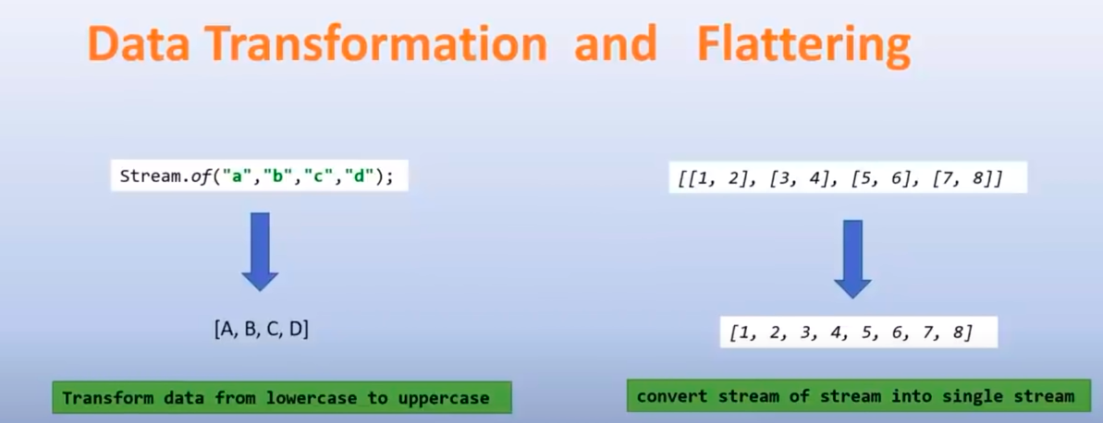

Map and Reduce:

Reduce is used to total the numbers.

Sum of Arrary

int[] A = { 1, 2, 3, 4, 5 };

int sum = Arrays.stream(A).sum();

int sum = Arrays.stream(A).reduce((x, y) -> x + y).getAsInt();

double average= Arrays.stream(array).average();

Convert Array to Stream:

Stream.of(a)

Arrays.stream(a)

Maximum Number in Array:

Arrays.stream(arr).max().getAsInt();

List<Integer> myList = Arrays.asList(10,15,8,49,25,98,98,32,15);

myList.stream().sorted();

Parallel Stream: Parallel Stream executes the streams in multiple cores Parallely.

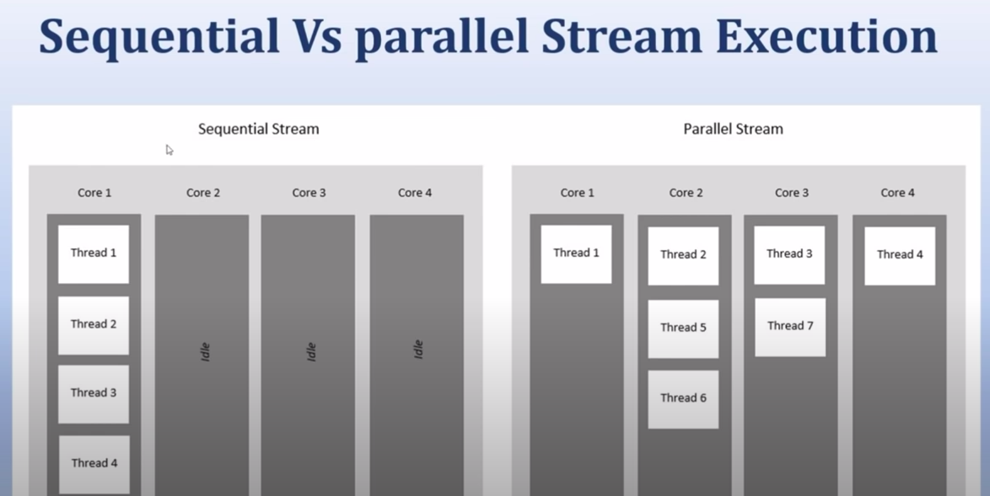

**Pagination, Sorting and Searching:**

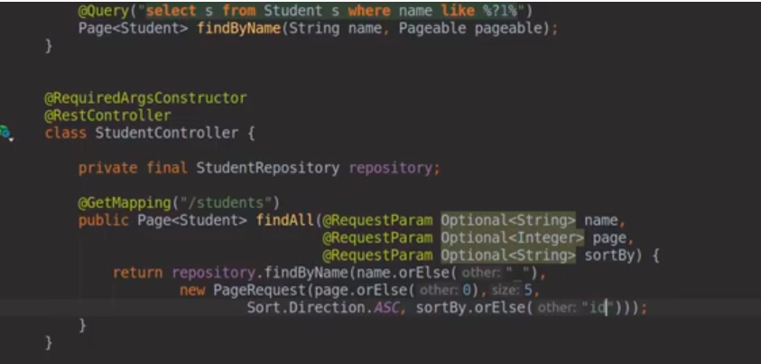

Spring Session:

Application.property: spring.session.store-type=jdbc

Spring-session-core, spring-session-jdbc two dependency

Two tables automatically create in the db: spring_session, spring_session_attributes

URL: <https://www.javainuse.com/spring/springboot_session>

Mokito Test Case:

<https://www.youtube.com/watch?v=qpK1AoFWY8k>

Spring boot batch:

Batch is the processing large data in the database.

Example: we need to insert the record into the database from the large CSV file data.

Fetch the large amount of data frequently and store in the file or any other storage.

JobLauncher: is the Interface used to launch the job.

Job launcher has a run method, when is called it create new component Job.

Job: the work that we need to execute.

JobRepository: Maintains the state of the job. If it’s the failed of success.

Job have **steps** with tree component= ItemReader = read, ItemWriter= write, ItemProcessor= process the data between read and write.

Job may have multiple steps as well.

